**IHC Voltage Binning User Manual**

**Warning: This test involves high voltage electricity. Exercise caution when near equipment**

**Note: Calibration is not required for any test equipment. This test is sanity check only.**

**Software Installation and Dependencies:**

To install the application first download the IHCVoltageBinning folder. Inside the folder should be the python script IHC-binning.py, the desktop launcher IHC-binning.desktop, and a folder named images containing image files necessary for the application to run. Once you’ve ensured that all the necessary files are present, you must run the script “dependencies.sh”. To do this type the command “bash FILE_PATH” where “FILE_PATH” is the path to “dependencies.sh”. You can get the path by right clicking the file and selecting “Copy Path(s)”. The script ensures that the following Python modules are installed on your machine:

* InstrumentKit
* time
* sys
* glob
* serial
* os
* Image, ImageDraw, ImageFont, ImageTk from Pillow
* tkinter
* numpy
* piplates

After all the dependencies are installed open the file IHC-binning.desktop with the text editor by right clicking on the file and selecting “Text Editor” from the drop-down menu. Replace the text “INSERT_SCRIPT_PATH_HERE” with the path of the file IHC-binning.py and “INSERT_IMAGE_PATH_HERE” with the path of the file the file appleton.png the located in the images folder. The easiest way to do this is to right click on each file, select “Copy Path(s)”, and paste the path in its proper location. Once this is done move IHC-binning.desktop to the desktop. Its icon should now be the Appleton logo.

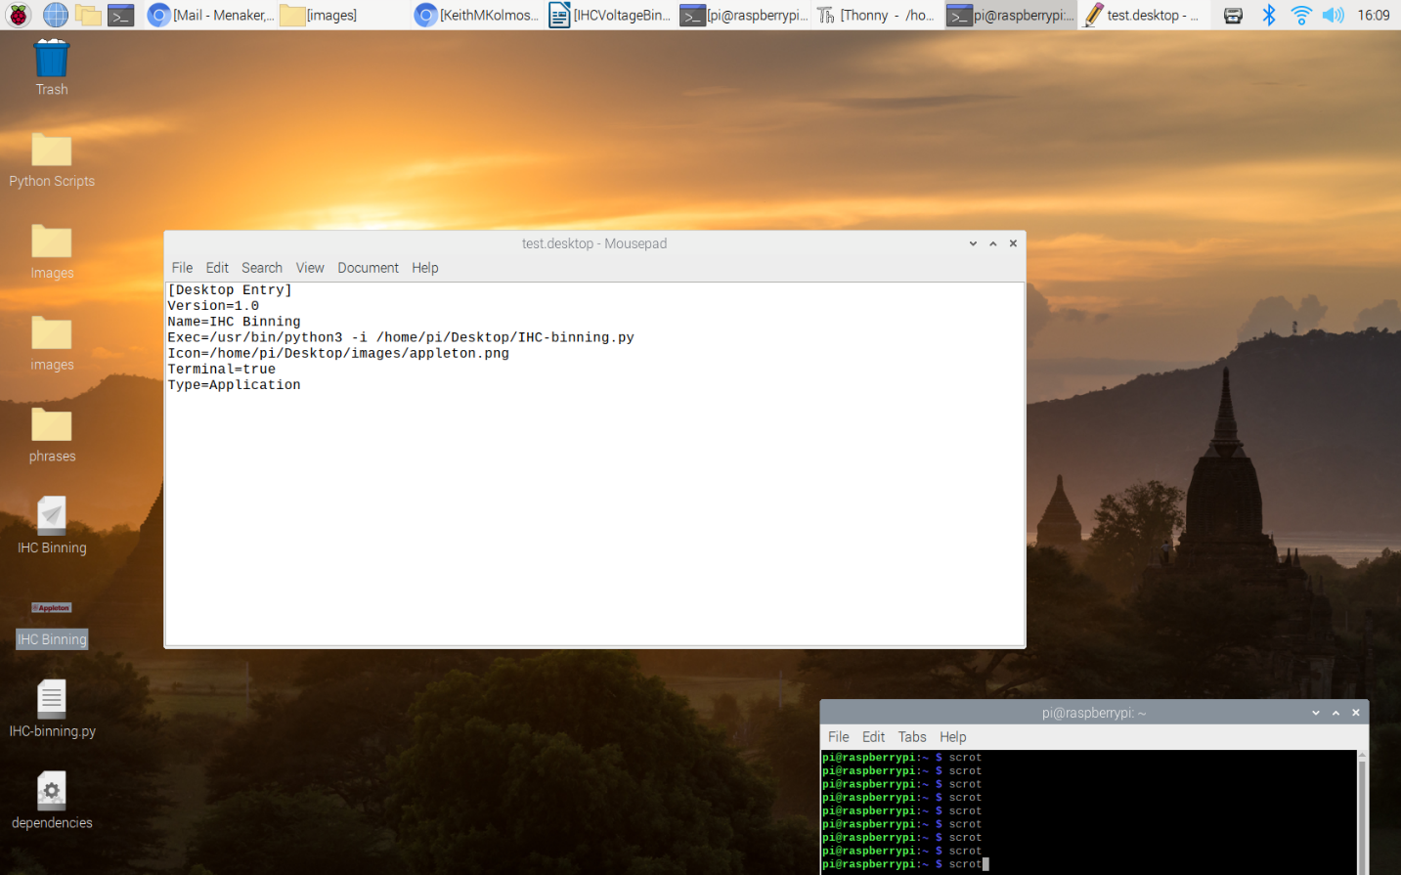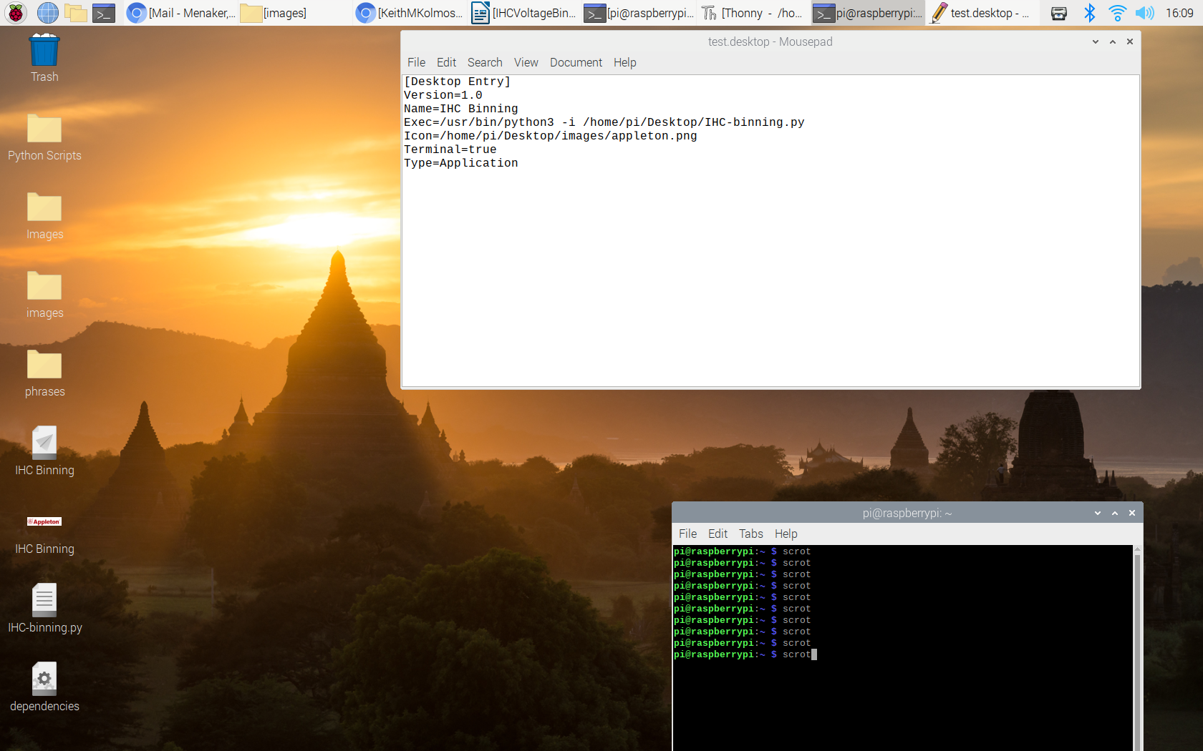

The final software installation task is to ensure that the icon and python script have permission to be executed. Open the terminal and type the following commands:

***chmod -x ~/Desktop/IHC-binning.desktop***

***chmod -x INSERT_SCRIPT_PATH_HERE***

Where “INSERT_SCRIPT_PATH_HERE” should be replaced with the path to IHC-binning.py like in the previous step. Once these commands have be executed all the prerequisite software has been installed.

**Hardware and Printer Setup:**

To setup the Raspberry Pi you must first install the Raspbian bootloader onto the SD card. Instructions to do this are available at <https://www.raspberrypi.org/documentation/installation/installing-images/>.

Once this is done attach the POWERplate and DAQC2plate to the Raspberry Pi following the instructions at <https://pi-plates.com/powerplate-users-guide/> and <https://pi-plates.com/daqc2-users-guide/>. The stack should be Raspberry Pi at the bottom, POWERplate on top of the Pi and DAQC2plate on top of the power plate.

Next, connect the power, display, and USB keyboard to the Raspberry Pi. Turn on the Pi and follow the setup instructions. Once the setup is complete, we can connect the other peripherals. Connect the barcode scanner first by plugging in the USB cable into the Pi. It should beep and the top indicator light will illuminate. Next, connect the multimeter USB dongle to the Pi. Now that we have connected our main peripherals, we will move on to printer setup.

To setup the printer, follow the setup instructions included with the label printer. Then power on the printer and connect the USB cable into the Raspberry Pi. Then click on the raspberry icon in the top left of the screen, select “Preferences” and then select “Print Settings”. Add the label printer. For the make select “Zebra”, choose the driver “ZPL Label” and use the recommended settings elsewhere. Don’t worry about the media size, the media size is automatically adjusted in the application.

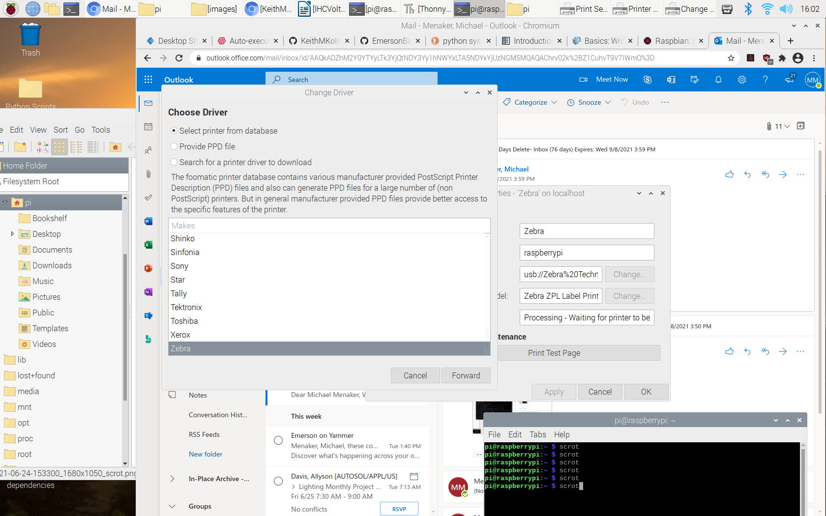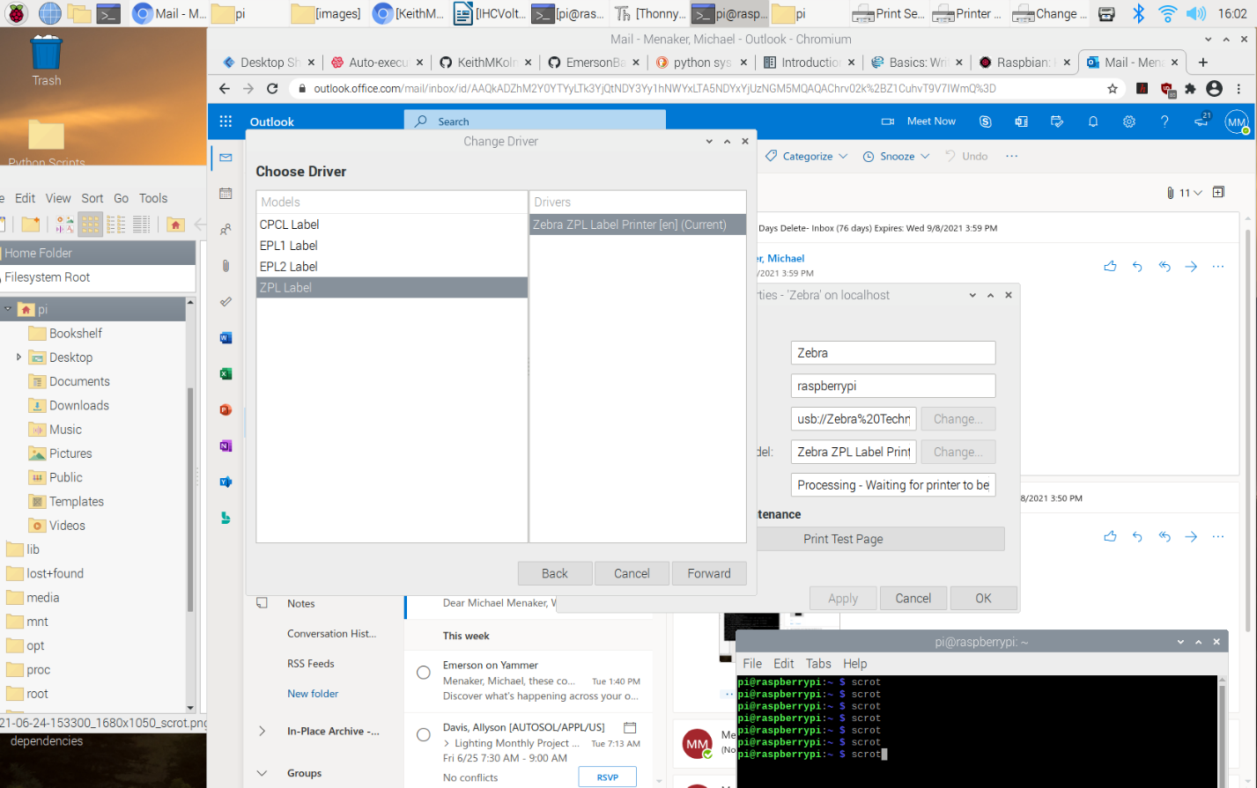

Once complete, right click on the new printer icon and rename it to your desired name.

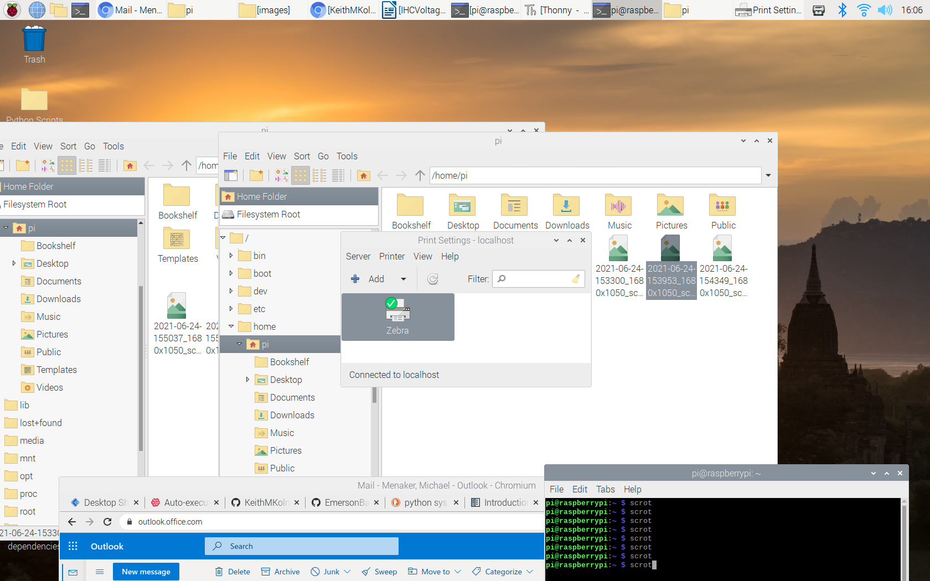

Next double click the printer and click on “Printer Options”. Ensure that the Resolution is 203dpi, Media Tracking is Non-continuous (Web sensing) and the Media Type is Direct Thermal Media.

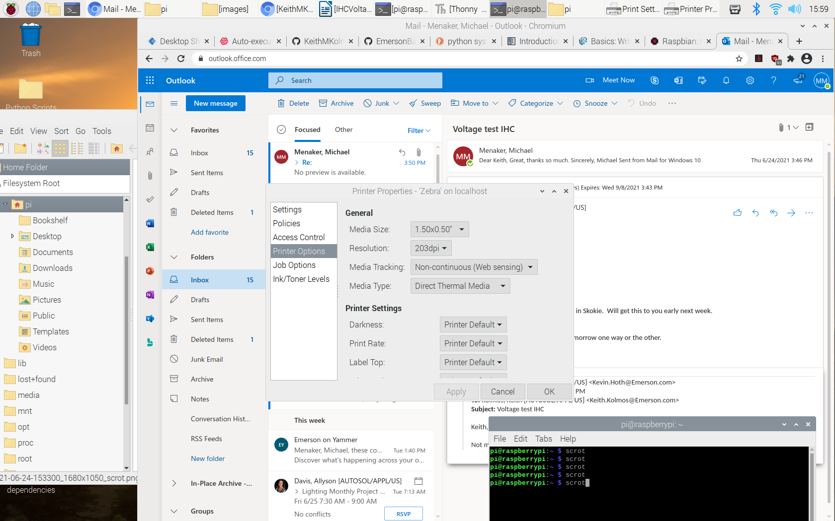

Once this is complete, we can test the printer by using the following terminal command: ***lp -o media=Custom 1x0.5in INSERT_TEST_IMAGE_PATH_HERE*** where you replace “INSERT_TEST_IMAGE_PATH_HERE” with the path to the test image located in the images folder. If the label prints incorrectly, retry the command. It often takes the printer a couple of prints for the printer to auto-align the label. If nothing prints, ensure that the printer is powered on and all printer settings are correct.

Once the printer properly prints, you have completed the printer setup process.

Finally, connect the solid-state relay board to the Raspberry Pi. The wiring diagram is below:

Connect to Power Supply V+

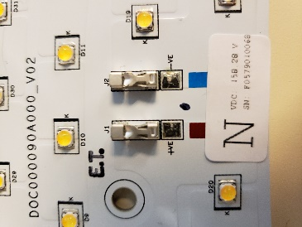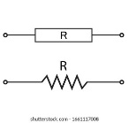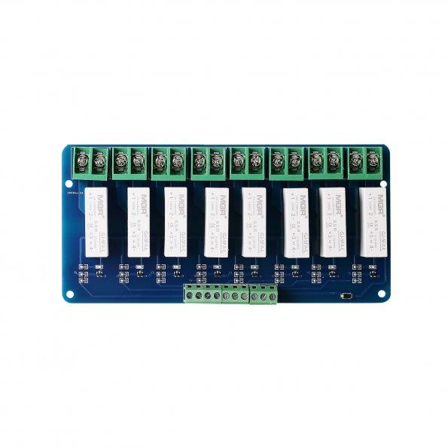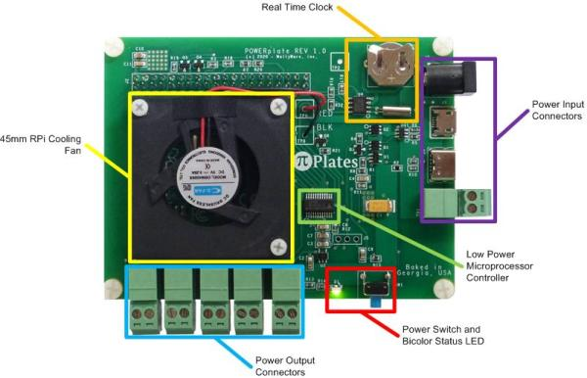

Connect to Digital Out 0 on DAQC2 Plate

R = 10K Ω

R = 330 Ω

Connect to Power Supply V-



Connect to +5V

Connect to Digital Out 0 on DAQC2 Plate

R = 5K Ω

**Warning: Do not turn on power supply until after the program is launched**

**IHC Voltage Binning Operation:**

To open the application double click the IHCBinning icon on the desktop. When first opening the application, you are presented with the following screen:

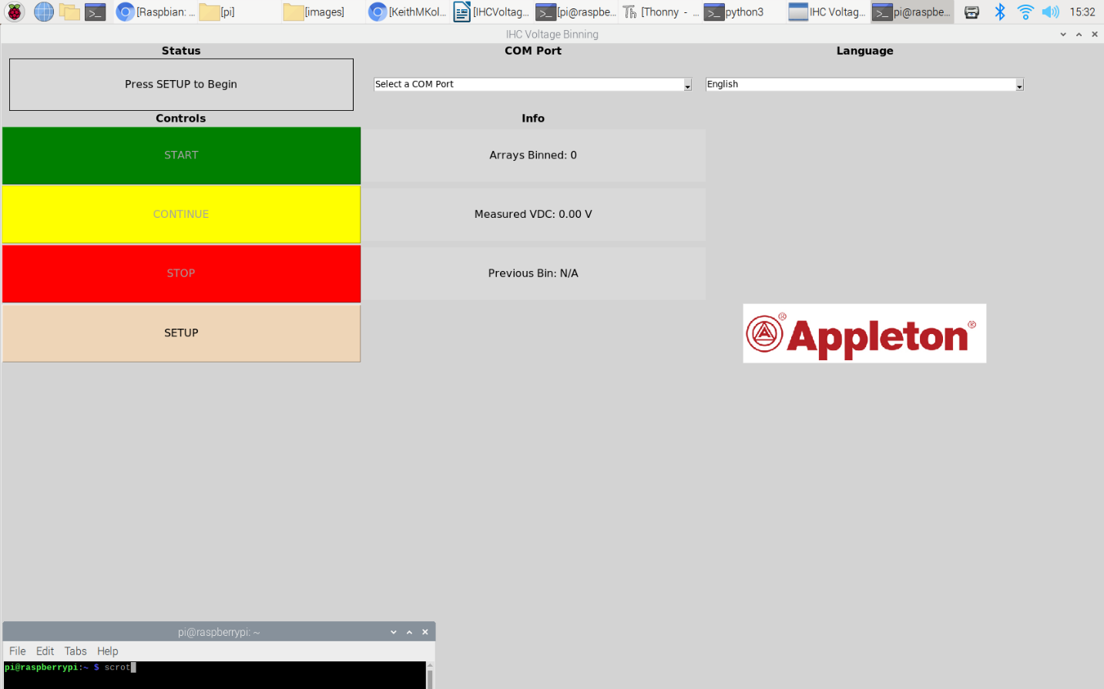

* To setup and establish connections with the peripheral devices press the SETUP button on the display. Before starting the setup ensure that the multimeter, barcode scanner and printer are properly connected to the Raspberry Pi.
* After selecting the SETUP button, you are prompted to select the COM port used for communication with the multimeter. Use the COM Port dropdown to select the serial port. The correct port will be of the form /dev/ttyUSBx where x is some number.

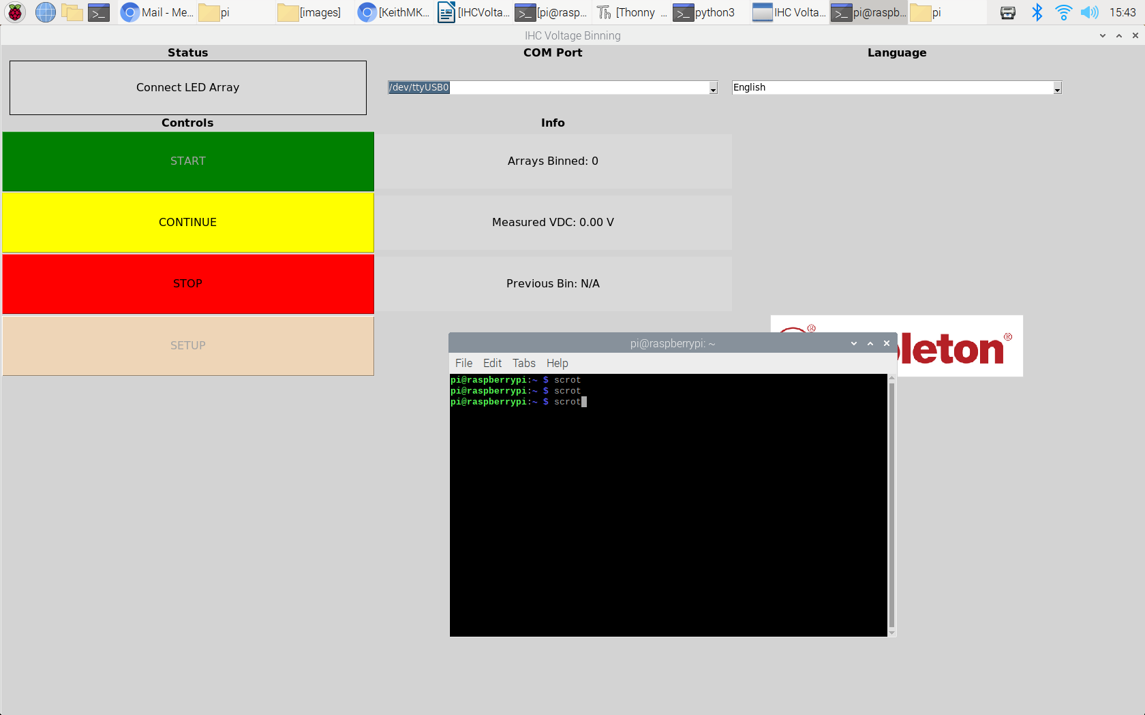

* Once you select the port and see it appear in the dropdown box press “Continue”.
* Next ensure that the printer is on and connected and press “Continue” again. The status field then should read “Done. Press Start to Bin”.
* To begin the binning process press “START”. A popup box should appear prompting you to scan a barcode:

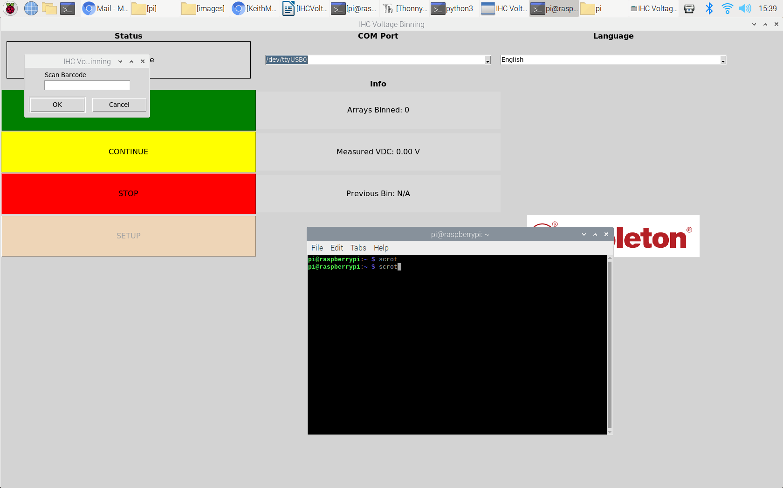

* Scan the array barcode with the barcode scanner. Once you do scan it the popup box will disappear, and you will be prompted to connect the LED arrays
* Place the LED array into the fixture and connect power leads. Ensure that the multimeter is connected and is powered on. The multimeter will shut off after several minutes of inactivity. If the multimeter screen is blank press the green button to turn it on. Power on the power supply and set the voltage to 180 VDC. You only have to do this once at the start of the binning procedure. Once you are sure the array, power supply, and multimeter are properly configured press the “CONTINUE” button to switch power to the array and take a measurement. The array will be driven for 5-10 sec before the measurement is taken.
* If the measurement was successful, the status field will say “Complete. Press start for next” and a label will be printed. If there is an error in the serial communication the status field will say “Serial failure. Press CONTINUE”. Upon pressing continue the program will terminate and the main window will close. If you encounter this error, ensure that the multimeter is on and the USB dongle is properly connected. If the error persists the terminal window will show the serial error in greater detail.

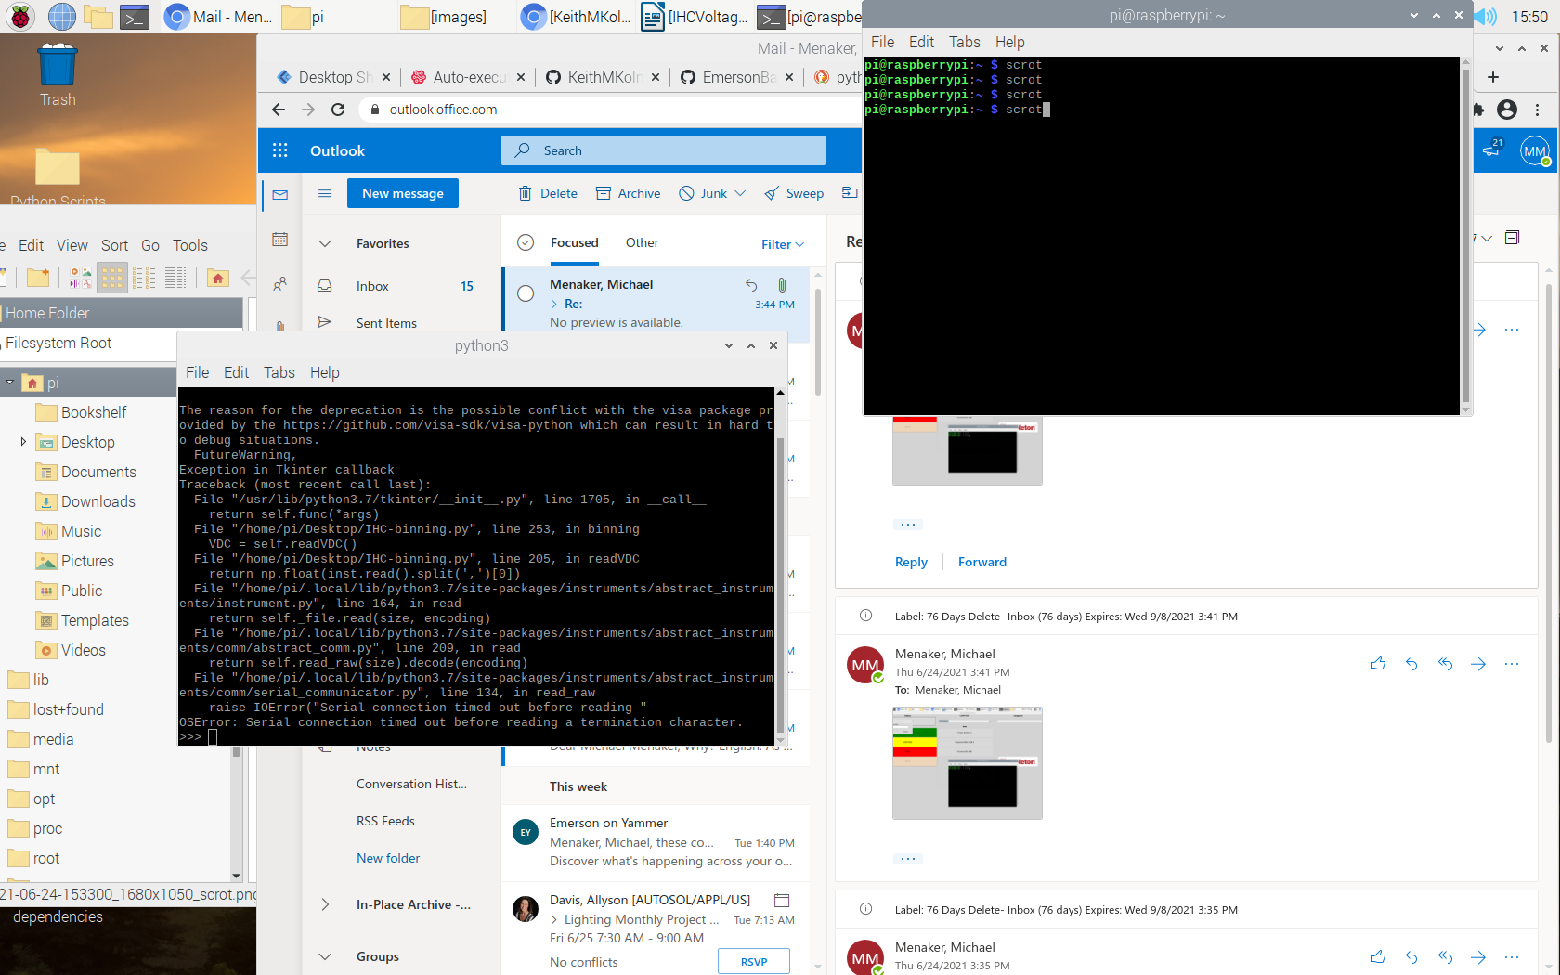

* To bin the next item press “START”. To stop the binning process press “STOP”

Notes:

-To stop the binning process at any point, press the “STOP” button

-To change the language, select a language from the language dropdown. The program will reset after the language is changed.



-As shown in the example terminal window, if the error “OSError: Serial connection timed out before reading a termination character.” appears it tells you that the multimeter isn’t responding to the query of the program. This is almost always due to an incorrect COM port selection, a disconnected USB cable, or a multimeter that is powered off.